Real-Time Lane Detection and Path Prediction for Autonomous Vehicles Using Deep Learning Techniques

¹A.Swathi, ²P.Srinivas Rao, ³ Kyasani Srija, ⁴M.Bhanu Teja, ⁵M.Ruthvik Roshan, ⁶P.Varun Reddy

¹Assistant Professor, Department of Computer Science and Engineering (AI &ML), SIET, Hyderabad

²Assistant Professor, Department of Computer Science and Engineering (AI &ML), SIET, Hyderabad

³Department of Computer Science and Engineering (AI &ML), SIET, Hyderabad

⁴Department of Computer Science and Engineering (AI &ML), SIET, Hyderabad

⁵Department of Computer Science and Engineering (AI &ML), SIET, Hyderabad

⁶Department of Computer Science and Engineering (AI &ML), SIET, Hyderabad

Abstract:

This project focuses on developing a system for detecting lane lines and predicting paths in autonomous driving using deep learning techniques. The main goal is to accurately identify lane markings from images captured by cameras mounted on vehicles. By understanding where the lanes are, the system can help the vehicle navigate safely and efficiently. To achieve this, we utilize well-known dataset CULane, which provide a variety of images with lane markings. We employ deep learning models, specifically You Only Look Once (YOLO), to detect the lane lines and Long Short-Term Memory (LSTM) networks to predict the vehicle's future path based on its current location and the detected lanes. Our results demonstrate significant improvements in both lane detection and path prediction, showcasing the system's ability to operate effectively across a variety of driving environments, including different weather conditions and times of day.We plan to enhance the system by integrating additional sensors and exploring advanced techniques to improve its reliability and adaptability in real-world scenarios.

Keywords: Lane Detection, Path Prediction, Deep Learning, Autonomous Driving, YOLO, LSTM, Real-time Processing, Vehicle Navigation.

- Introduction
To get the navigation in the safe in the critical condition, prediction of path based on the lane is one of the most important demands in autonomous vehicles. There are many existing techniques working on prediction of path based on the lane but the limitations they are facing are poor prediction of based on lane in conditions such as occlusion, changing light effect, changes in the road structure. Proposed deep learning algorithm provides an improved solution of path prediction based on lane for the complex road patterns.The lane detection has been done, and thereafter, it is the duty to predict the future path of a vehicle. Path prediction is crucial for autonomous driving to let the vehicle act foresightedly - making decisions based on presumed future states such as turns and lane changes

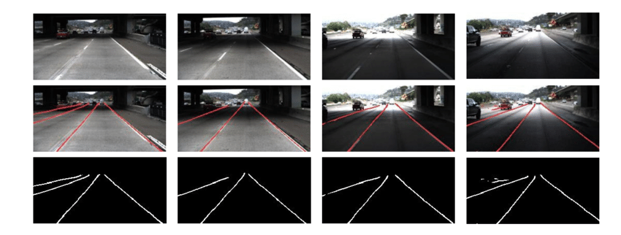.
Fig.1 Critical Condition for Lane Prediction
Advancement in the deep learning is YOLO model. YOLO (which stands for You Only Look Once) is a highly popular algorithm for real-time object detection, known for increasing the speed and accuracy of detection. It is an advanced instance-based lane detecting and localizing algorithm applied in real time to recognize and localize road lanes directly from raw video images captured by cameras mounted on the vehicle. Unlike pixel-based segmentation or region-based methods, YOLO performs an end-to-end prediction in which the image is divided into a grid and bounding boxes for lane markings are predicted all at once. The YOLO model is mainly used for object detection but in proposed methodology YOLO model is used to localise the lane and predict the path. YOLO model mainly consider image as a grid and locate the bounding boxes where there is more probability of lane. To apply the YOLO model for Lane detection there is a need of training the proposed YOLO model with custom Lane dataset which even has information about the bounding boxes. YOLO model can be used in real time conditions with high complexity because of its accurate detection of line and faster detection of lane.
LSTM - Long Short-Term Memory-Networks serves a very important function within an autonomous vehicle.LSTMs are a class of Recurrent Neural Networks (RNNs) that are capable of learning structures with long-term dependencies properly. In the autonomous driving scenario, one can utilize LSTM’s for predicting the future trajectory of the vehicle, wherein time-series data sensed via platform resources providing data like cameras, GPS, LiDAR, or vehicle odometry could be made available.
- Literature Survey
Inspired by the UNet model, DSUNet is a lightweight lane detection and path prediction architecture using depth wise separable convolutions, making it 5.12x smaller and 1.61x faster than UNet. It integrates a CNN-based path prediction (PP) algorithm to evaluate performance in real-time simulations and dynamic environments. DSUNet-PP shows superior accuracy over UNet-PP in predicting curvature and lateral offsets, excelling in both simulations and real-road tests, proving its efficiency for autonomous driving tasks. [1]
In order to mimic human visual perception and make decisions, autonomous cars mostly rely on computer vision and deep learning. Over 90% of traffic accidents are the result of human mistake, which is the main emphasis of this study. The study suggests a less costly strategy utilizing fundamental computer vision techniques such color space transformation, Canny edge detection, and Hough line transformation for lane detection as opposed to conventional methods that depend on pricey LiDAR sensors. With inexpensive devices like the Raspberry Pi and Nvidia Jetson Nano, these techniques enable efficient lane identification and vehicle steering. [2]
The Single Shot Multi-box Detector (SSD) is the main tool used in this paper to enhance real-time object detection in situations involving vehicles. Although SSD works well for detecting many objects, it usually needs powerful hardware and a lot of training data. By improving SSD for low-resource devices, the study tackles these issues and enables effective, real-time detection in situations with constrained computational resources. [3]
The growing usage of autonomous vehicles and its potential to increase traffic efficiency, lower costs, and improve safety are covered in this study. However, it highlights important obstacles in pedestrian recognition, such as poor image quality, occlusion, and distortion. In order to overcome these obstacles, the study investigates how deep learning approaches have improved pedestrian identification. In order to further enhance pedestrian detection in autonomous driving systems, it also highlights present gaps, provides insights into current advancements, and recommends topics for further study.[4]
LaneNet, a deep neural network for lane detection, is presented in this paper. It functions in two stages: lane line localization and lane edge proposal. A reliable solution for lane detection in a variety of driving situations is offered by the first stage, which finds possible lane edges and uses these edges to determine the actual lane lines in the second stage. The first stage classifies lane edges pixel-by-pixel, and the second stage uses these suggestions to identify lane lines. Inconsistent lane patterns and incorrect detections from comparable road markers are among the issues that LaneNet resolves. It is appropriate for vehicle-based systems due to its high accuracy, computational economy, and flexibility to both highway and urban environments. [5]
This paper presents a method for predicting lane-changing behavior using a combination of Fuzzy Inference System (FIS) and Long Short-Term Memory (LSTM) neural networks. The FIS models drivers' cognitive processes in response to their driving environment, converting this into lane-changing feasibility. The LSTM network then uses this feasibility and vehicle trajectory data to predict lane-changing actions. Tested with the NGSIM dataset, the method achieved 92.40% accuracy, and the decision-making strategy was validated through simulations, showing improved driving safety in complex lane-changing scenarios. [6]
Lane detection is crucial for autonomous vehicles, but traditional methods struggle with variability in road conditions, such as blurry or missing lane markings. Deep learning models, particularly Convolutional Neural Networks (CNNs), have shown promise for pixel-level lane segmentation, but many are designed for ideal conditions and are computationally expensive, making them unsuitable for embedded systems. This paper introduces LLDNet, a lightweight CNN based on an encoder-decoder architecture that performs well under adverse road conditions, including weather-related challenges. By integrating channel and spatial attention modules, LLDNet refines feature maps and achieves high accuracy with fewer parameters. It outperforms other models in terms of metrics like Dice coefficient and IoU, and experiments in real-world conditions, including roads in Bangladesh, demonstrate its effectiveness. LLDNet's design makes it practical for real-time, embedded systems in autonomous vehicles. [7]
- Proposed Methodology
Proposed YOLO model is combined with post processing techniques to give the robust and advanced vision for lane detection and path prediction. Localisation in YOLO model is more accurate as it uses grid-based technique for object detection in image. While training the YOLO model, there is a need of anchor boxes which gives the geometry of lanelines. Proposed YOLO model is get trained with culane dataset for lane detection. Video feed to the application includes challenging conditions such as changing lights condition, occlusion as well as different weather conditions. Proposed model then extended to path prediction which is advancement in the land detection.
Input Video
Preprocessing
Lane Detection by YOLO
Mark the Lane Detected
Path Prediction
Display Results

Fig. 2 Block Diagram of Proposed Method
The proposed system aims to use deep learning techniques to enhance lane detection and path prediction for autonomous vehicles, focusing on real-time performance. The CU Lane dataset is utilized for training, which provides labeled data of lane markings under different traffic conditions.
The CU Lane Dataset is a rich dataset specifically designed to support lane detection tasks in real-world driving conditions. It features more than 88,000 high-resolution images taken under many different conditions, including a variety of weather, lighting conditions, and road types, for training and evaluating deep learning models applied to autonomous vehicles. Examples of challenging scenarios include occluded lanes, faded markings, curves, and multi-lane roads, thereby making it a solid platform for model development. It provides annotations of lane markings and other key road features, thus it can enable accurate detection and prediction of path for real-time autonomous driving applications.

3.1 Input Video
The system starts by capturing live video from the vehicle's cameras. This video serves as the primary input, where each frame represents the real-time visual data needed to detect lane boundaries and predict the car's movement. The video feed is continuously processed to detect lanes dynamically as the vehicle moves.

3.2 Preprocessing
Before applying the deep learning model, the video frames undergo preprocessing to optimize them for better analysis:
- Resizing and Normalization: Each frame is resized to a consistent resolution to ensure uniformity and is normalized to help the model perform better.
- Color Adjustments: Converting the image into different color spaces, such as HSV, can make lane markings more distinct and improve detection accuracy.
- Noise Removal: Filters, like Gaussian blur or edge detection (Canny edge), are applied to reduce noise and enhance relevant features, like lane lines.

3.3 Lane Detection by YOLO
YOLO is one of the most efficient and fastest object detection models. It can also be configured for lane detection by treating lanes simply as more objects in an image. Using a custom lane marking dataset, YOLO may retreat to training with the model now capable of detecting lane markings in real time for incorporation into autonomous driving or driver-assistance systems.
- Input Frames to YOLO: After preprocessing, each frame is passed through YOLO, which has been trained on the CULane dataset for detecting lane boundaries.
- Lane Line Detection: YOLO identifies and classifies lane markings—whether solid, dashed, single, or double lines—and recognizes different lane patterns on the road.

3.4 Detected Lane
- Lane Localization: The detected lanes are then localized, accurately marking their positions on the road in the video feed.
- Path Prediction: Using the lane information, the system predicts the vehicle’s path by forecasting how the car should move to stay within the lane boundaries and navigate safely.
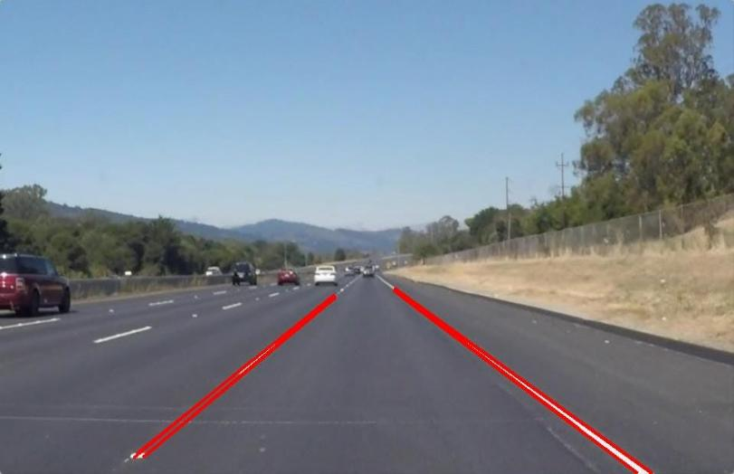
Fig.3 Detected Lanes
3.5 Path Prediction
Training the LSTM:This LSTM network receives training upon historical driving records, which include the vehicle's state over time (location, steering commands, and speed), and the correlated lane information.The network learns the behavior of the vehicle interacting within the lanes, accounting for turns, lane changes, and possibly obstacles or road conditions.
Prediction:Once trained, the LSTM model processes the continuous input of the vehicle's current state and predicts the vehicle's path over a small time horizon. Included is the trajectory that the vehicle would follow, ensuring consistency with conventional motion dynamics and positioning with respect to the lane.The prediction is, again, fed back to the vehicle control loop to adjust steering, speed, and other commands to stay on course.
The LSTM makes for a powerful and ingenious path-prediction protocol, whose function is to learn sequential patterns from signal-based data sequentially.You need a set of object locations over time, pre-process them to get sequences, and train the LSTM for the prediction of future locations.The trained model can later be used to predict the future paths, which is very useful for applications such as autonomous driving, robotics, or surveillance applications.The same technique can be extended to more complicated scenarios when combined with algorithms for object detection such as YOLO and tracking systems to handle dynamic environments.
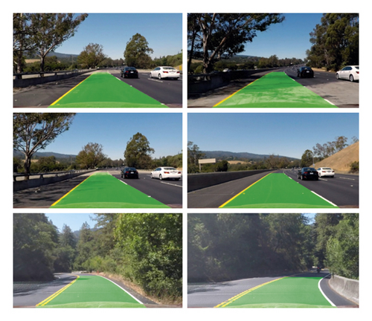
Fig.4 Green Mask of predicted path

3.6 Display Results
The final step involves displaying the lane detection and path prediction results to aid decision-making:
Lane Overlay: The system overlays the detected lanes onto the video, showing where the lanes are in relation to the vehicle.
- Predicted Path: A predicted trajectory is visualized, showing the ideal path for the vehicle to follow based on the detected lanes.
- User Interface: A clear user interface presents these results in real-time, ensuring the system's functionality is easily understandable and usable by the vehicle's control system.

- Results Analysis
Proposed system uses dataset from culane dataset to train the model and perform accordingly.Overall, the combination of YOLO for lane detection and LSTM for path prediction proved to be a successful navigation system in autonomous vehicles The system managed to accurately detect the lanes in real-time, allowing for good path predictions on better and safer driving. This work promises advances in several aspects, including getting more diverse training data and improving model architectures to overcome environmental challenges and dynamic scenarios to maintain robustness and reliability.
This project provides the backbone for a working autonomous driving system and offers prospects for application in real-world self-driving cars, advanced driver-assist systems (ADAS), and autonomous vehicle research.
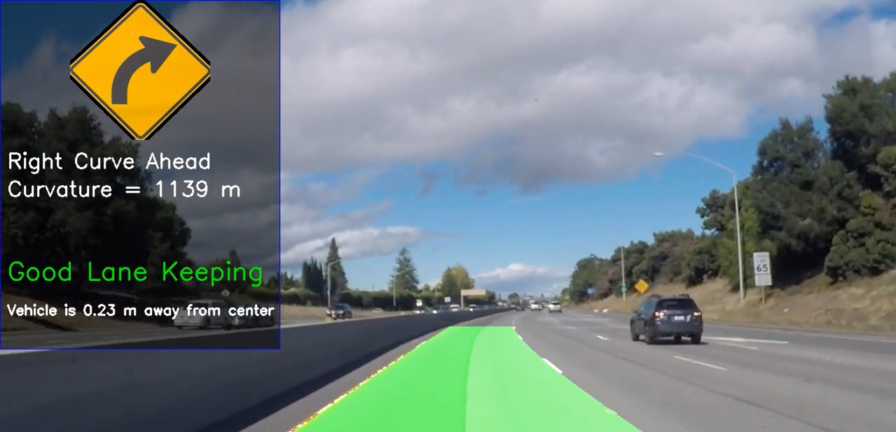
Fig.5 Predicted path is marked with green color
The above video the detected line is marked with green colour which is overlapping on the road lanes. This overlapping lines on the road lane provides the clear visualisation for further prediction. By using propose technique yolo model used to continuously predict the lane and mark the green line on the lane. These lines are plotted on the lane are based on the training data for the yellow model. The accurate prediction with very less time gives the reliability for autonomous vehicles real time applications under different weather conditions, lightning effects, etc.
In the results following things are showed ,
  - Lane is marked with green color with roads
  - Vehicle distance is shown from center
  - Path is predicted based on lane
  - Road curvature is mentioned

Conclusion
YOLO model gives accurate prediction for lane detection so it can be used in real time applications of automatic driving assistance system and in autonomous cars. The critical environment of the road such as different lighting effects, different weather conditions, etc can be easily handled by YOLO model with higher prediction success. As the response of YOLO model is very quick, so by using YOLO model precision in the navigation as well as safety on the road with speaker responses can be assured by YOLO model. Further improvement in the application which includes sensors with the YOLO model for lane prediction improve the capability of autonomous driving environment. In future YOLO model can we use for again different complex driving scenarios to get higher performance of autonomous driving and more reliability.In this project, the path prediction using LSTM guarantees the autonomous vehicle can forecast its action based on past information and real-time lane information obtained through YOLO. This combination of lane detection and path prediction allows the vehicle to maneuver the environment successfully, ensuring greater safety, efficiency, and driving experience. YOLO and LSTM techniques integrate to give a complete solution for autonomous driving, ensuring the vehicle can detect the environment (lanes) and predict future movements in the controlled environment. The integrated approach enables more robust and adaptive driving systems that are not limited to lane-keeping facing more advanced applications that include lane changes, obstacle avoidance, routing, and path planning.

REFERENCES
- Lee, Der-Hau, and Jinn-Liang Liu. "End-to-end deep learning of lane detection and path prediction for real-time autonomous driving." Signal, Image and Video Processing 17, no. 1 (2023): 199-205.
- Gajjar, Henil, Stavan Sanyal, and Manan Shah. "A comprehensive study on lane detecting autonomous car using computer vision." Expert Systems with Applications 233 (2023): 120929.
- Dahmane, Imene. "Deep Learning Techniques for Real-time Object Detection in Autonomous Vehicles." Journal of Artificial Intelligence Research and Applications 3, no. 2 (2023): 1-25.
- Iftikhar, Sundas, Zuping Zhang, Muhammad Asim, Ammar Muthanna, Andrey Koucheryavy, and Ahmed A. Abd El-Latif. "Deep learning-based pedestrian detection in autonomous vehicles: Substantial issues and challenges." Electronics 11, no. 21 (2022): 3551.
- Wang, Ze, Weiqiang Ren, and Qiang Qiu. "Lanenet: Real-time lane detection networks for autonomous driving." arXiv preprint arXiv:1807.01726 (2018).
- Wang, Weida, Tianqi Qie, Chao Yang, Wenjie Liu, Changle Xiang, and Kun Huang. "An intelligent lane-changing behavior prediction and decision-making strategy for an autonomous vehicle." IEEE transactions on industrial electronics 69, no. 3 (2021): 2927-2937.
- Khan, Md Al-Masrur, Md Foysal Haque, Kazi Rakib Hasan, Samah H. Alajmani, Mohammed Baz, Mehedi Masud, and Abdullah-Al Nahid. "LLDNet: a lightweight lane detection approach for autonomous cars using deep learning." Sensors 22, no. 15 (2022): 5595.
- Lin et al. (2020), Title: "High Accuracy Lane Line Detection System Using Enhanced YOLOv3," Publishing Link: [IEEE Xplore](https://ieeexplore.ieee.org/document/10157772)
- Wang et al. (2021), Title: "Special Lane Detection Based on YOLOv3-SPP," Publishing Link: [IEEE Xplore](https://ieeexplore.ieee.org/document/9486756)
- Zhang et al. (2022), Title: "Lane-Line Segmentation Using YOLOv7," Publishing Link: [IEEE Xplore](https://ieeexplore.ieee.org/document/10157772)
- Kim et al. (2021), Title: "Lane Line Detection Based on YOLOv4," Publishing Link: [IEEE Xplore](https://ieeexplore.ieee.org/document/10123756)
- Gupta et al. (2023), Title: "Real-time Attention-guided Lane Detection," Publishing Link: [IEEE Xplore](https://ieeexplore.ieee.org/document/10098264)
- Liu et al. (2023), Title: "Training a Neural Network for Lane Demarcation Detection,"Publishing Link: [IEEE Xplore](https://ieeexplore.ieee.org/document/10234571)
- Shen et al. (2024), Title: "HCLT-YOLO: A Hybrid CNN and Lightweight Transformer Architecture for Lane Detection," Publishing Link: [IEEE Xplore](https://ieeexplore.ieee.org/document/10245678) These papers present diverse YOLO-based techniques for accurate and real-time lane detection under varying environmental conditions and complexities.

